XWM – MySQL

TODO

Contents

Install – MySQL on Ubuntu 2

Create the virtual machine ‘xwm-mysql’ 2

Name and operating system 2

Memory size 2

Hard disk 3

Hard disk file type 3

Storage on physical hard disk 3

File location and size 4

Install Ubuntu 5

Download Ubuntu 5

Configure ‘xwm-mysql’ to boot from the installation image 6

Create a Virtual Box snapshot 8

Bridge the network connection 9

Install deja-dup and do a backup 10

Remote desktop using xRDP 12

Configure the firewall for RDP 12

Remote onto xwm-mysql 13

Install MySQL 14

Create a new user on ‘xwm-mysql’ 15

Login to MySQL as admin 15

Change the root password 16

Create a MySQL database 17

Create a MySQL table 18

Insert a row into a table 20

Create backups 21

MySQL backup (mysqldump) 21

mysqldump 21

# Install – MySQL on Ubuntu

# Create the virtual machine ‘xwm-mysql’

To create a new Virtual Machine in Virtual Box

select: Machine > New

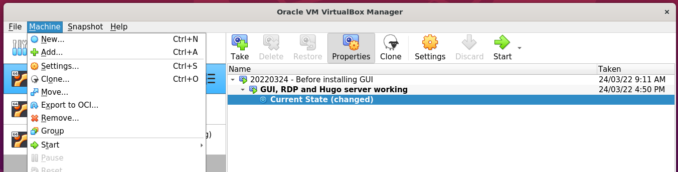

### Name and operating system

Name: xwm-mysql

Folder: /media/nath/4TB/XWM

Type: Linux

Version: Ubuntu (64-bit)

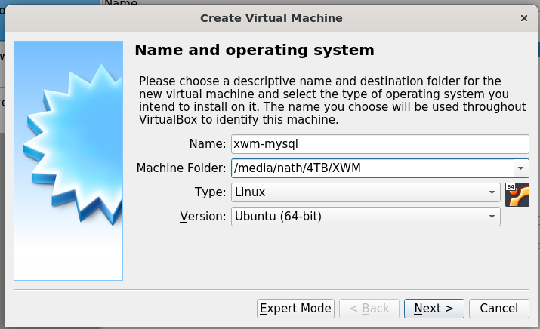

### Memory size

Select: 4096 MB

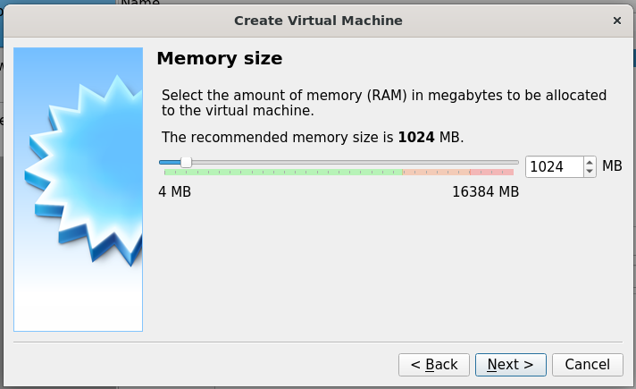

*Next, Hard disk …*

### Hard disk

Select: Create a hard disk now

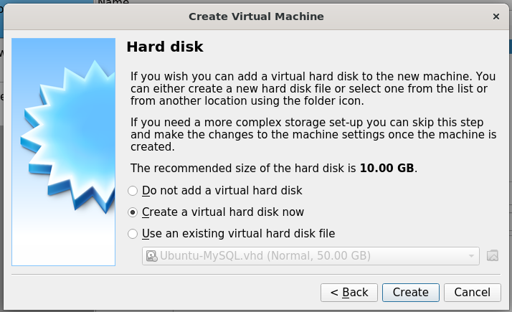

### Hard disk file type

Select: VHD (Virtual Hard Disk)

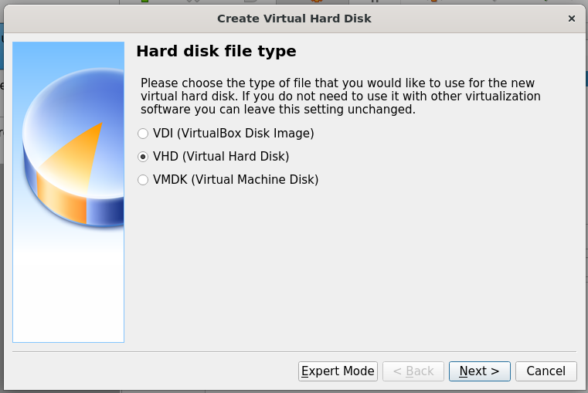

### Storage on physical hard disk

Select: Dynamically allocated

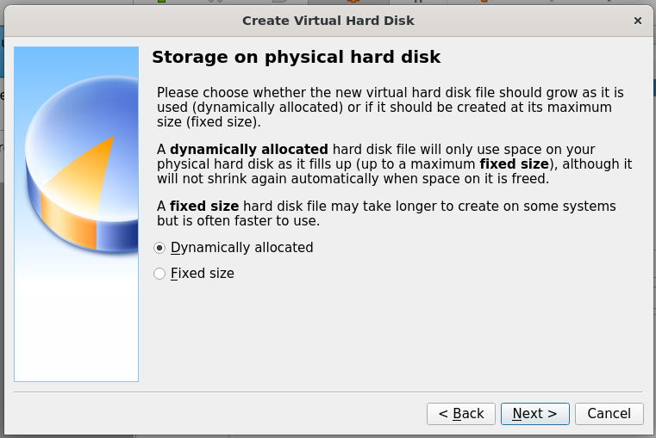

*Next, File location and size …*

### File location and size

Location: /media/nath/4TB/XWM/xwm-mysql/xwm-mysql.vhd

Size: 50 GB

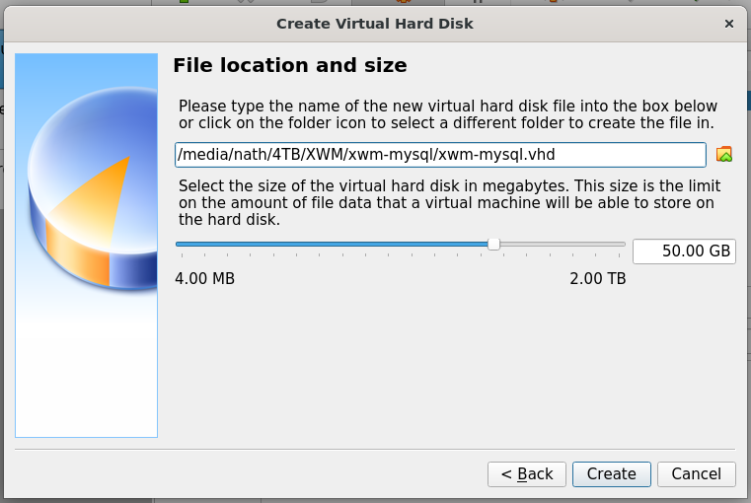

Click: Create *(above)*

The virtual machine xwm-mysql

is displayed in the left column Virtual Box.

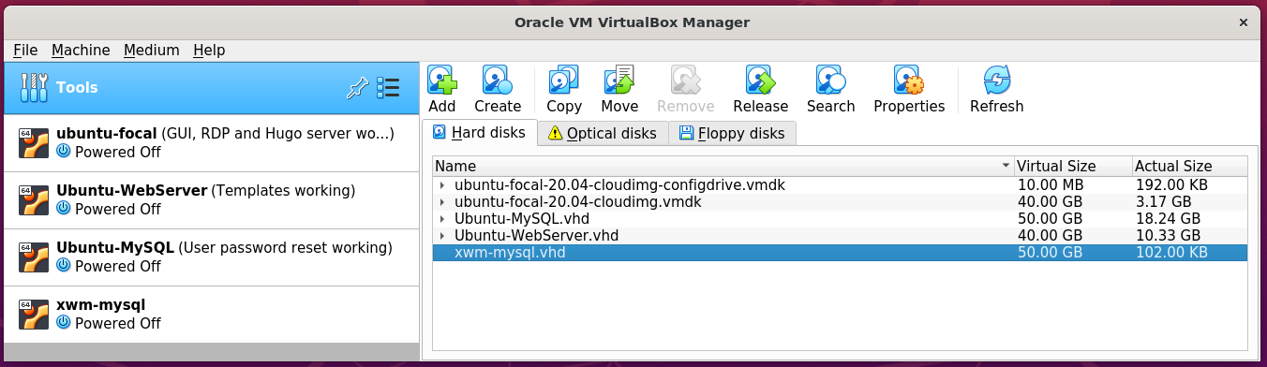

*Next, Install Ubuntu …*

# Install Ubuntu

### Download Ubuntu

Download the latest version of Ubuntu,

from: https://ubuntu.com/download/desktop

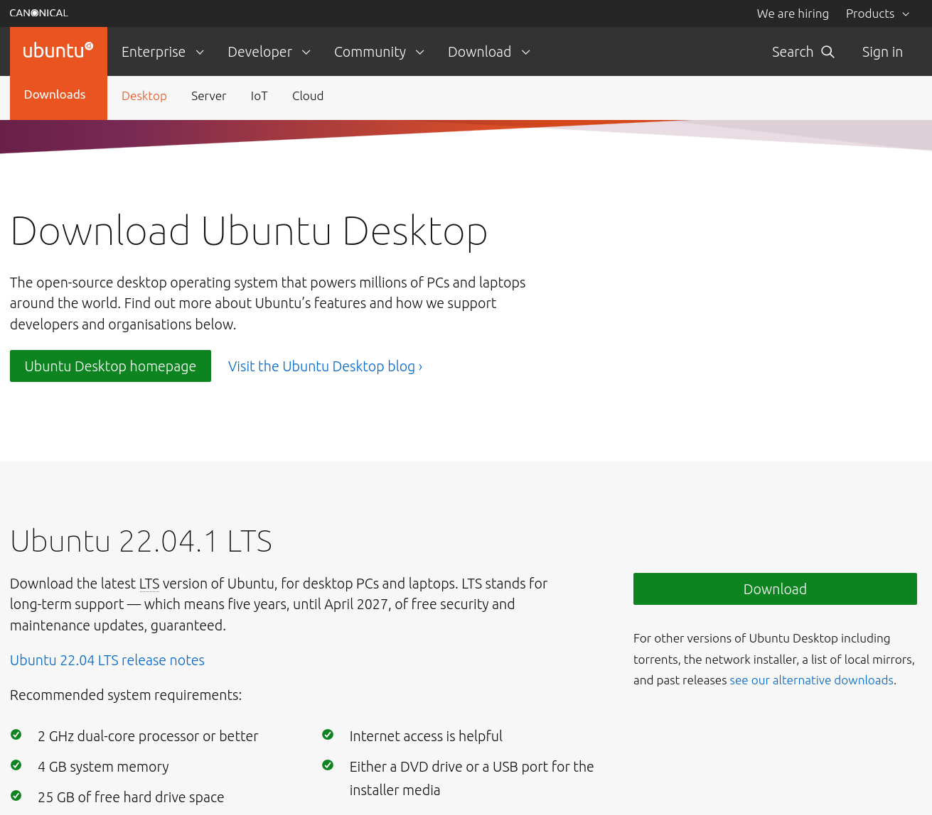

*Next, Configure* ***xwm-mysql*** *to boot from the installation image*

### Configure ‘xwm-mysql’ to boot from the installation image

Open Virtual Box on the host server Ubuntu-LAMP

In the left column

right click the virtual machine xwm-mysql

and select Settings

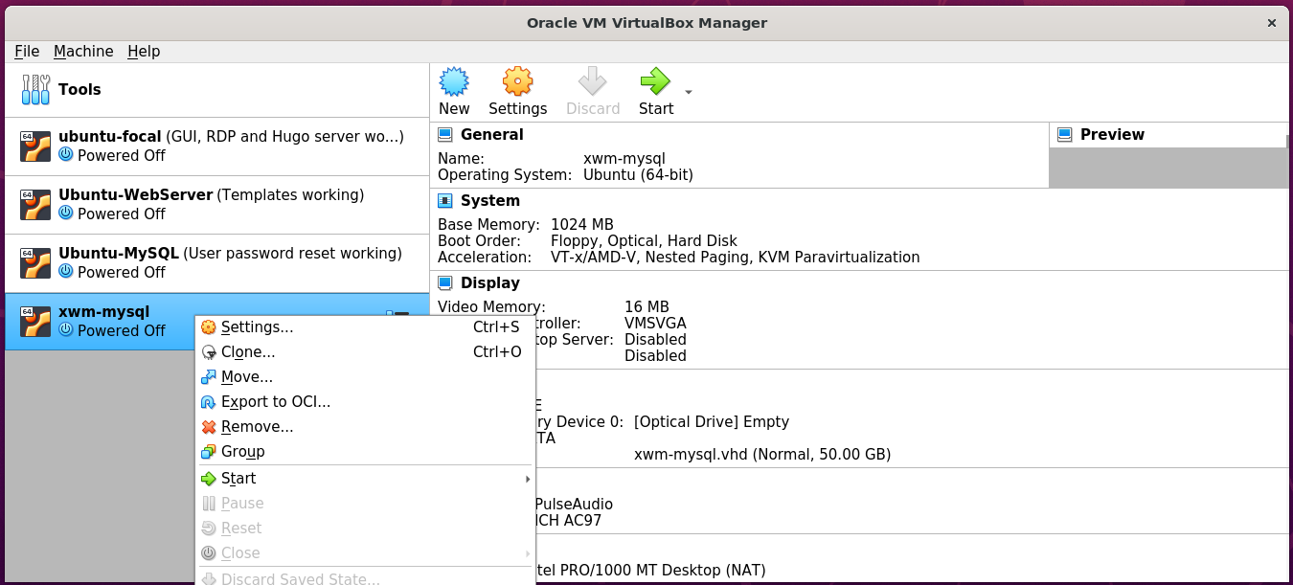

In the left column of Settings

select Storage

then in the middle panel

select Controller: IDE

on the right

select Choose a disk file

and select the downloaded Ubuntu installer

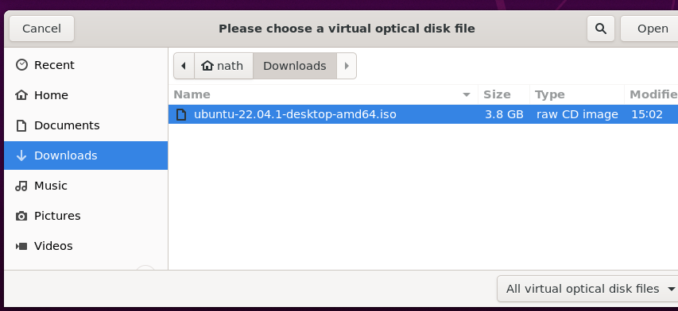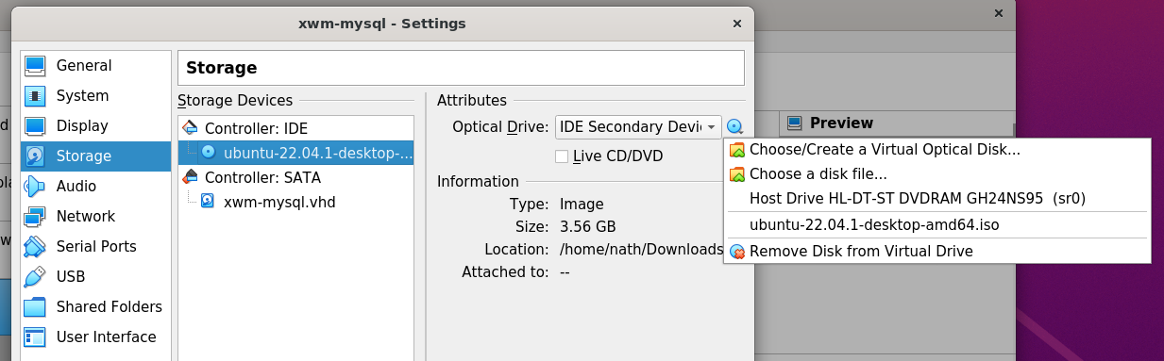

Now that installation iso has been selected

as the virtual machines CD

When the VMS starts-up it will install Ubuntu.

Start the virtual machine xwm-mysql

By clicking Start > Normal Start

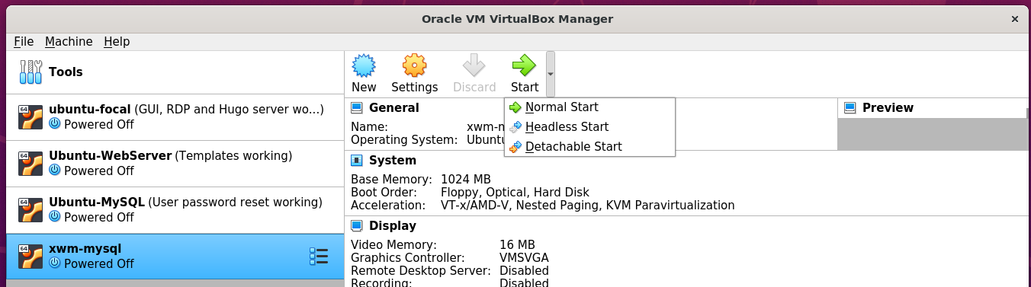

When the boot options are displayed

select: Try or install Ubuntu

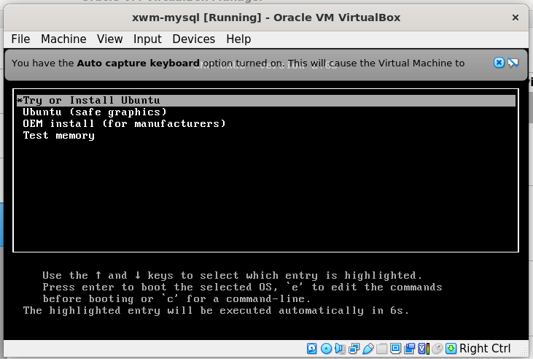

Follow the installation prompts to install Ubuntu

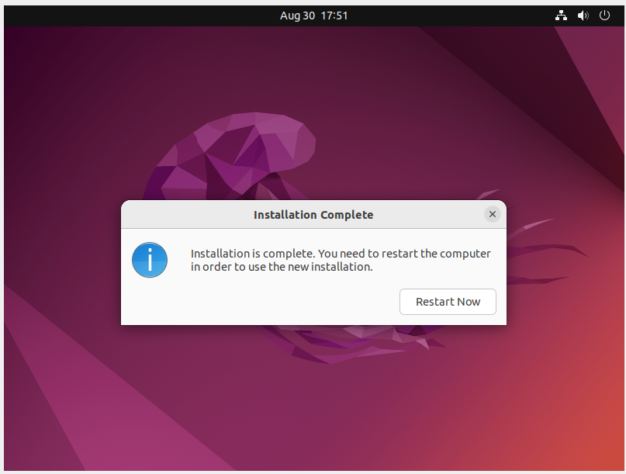

Shut down xwm-mysql

remove the installation iso

then restart the vm

to complete the installation.

*Next, create a snapshot …*

## Create a Virtual Box snapshot

Once the installation completes

shutdown the virtual machine

and create a snapshot of xwm-mysql

Create a snapshot

of the newly installed virtual machine xwm-mysql

In the left menu of Virtual Box

click xwm-mysql’s settings icon *(the waffle)*

and click Snapshots

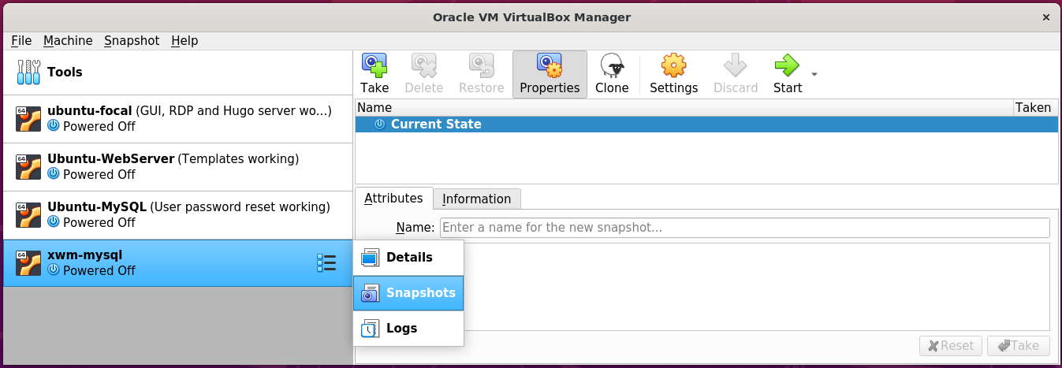

Then on the right, click the Take icon.

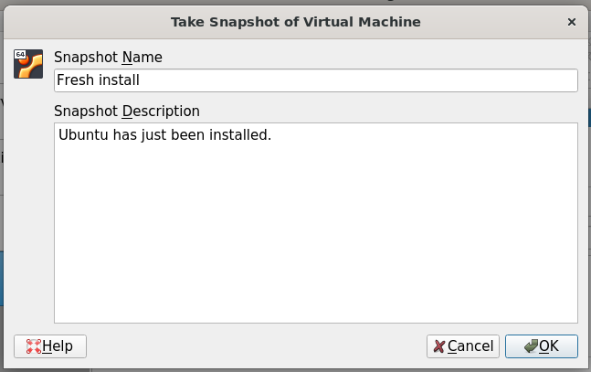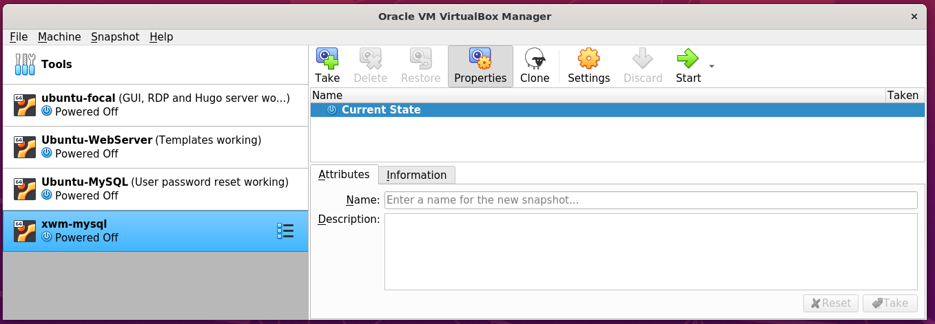

## Bridge the network connection

xwm-mysql is currently on it’s on virtual network.

To allow it to communicate with other devices on the network

right click xwm-mysql from Virtual Box’s left menu

and select settings

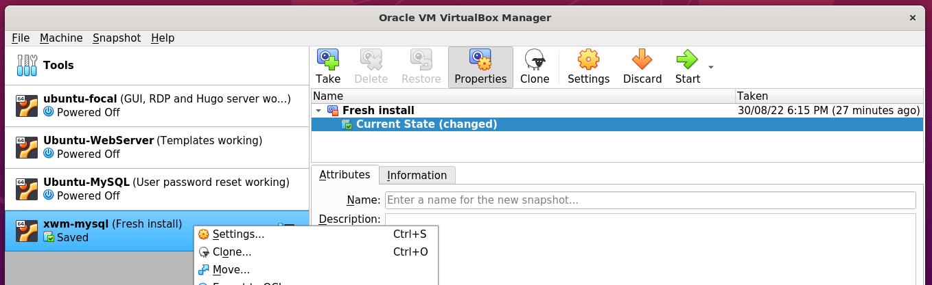

In Setting’s left menu

select Network

Set ‘Attached to’ to: Bridged-Adapter

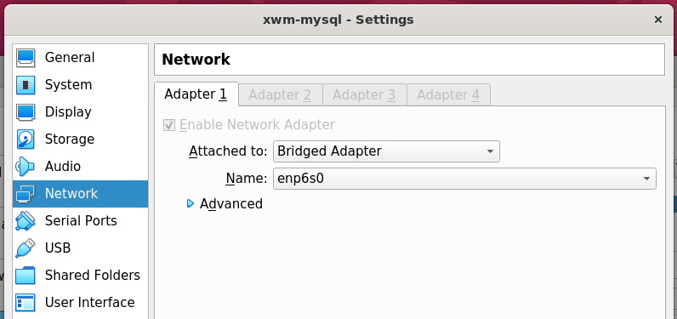

## Install deja-dup and do a backup

https://www.howtoinstall.me/ubuntu/18-04/deja-dup/

In terminal, run the following command:

sudo apt update

sudo apt install deja-dup

#### Example – Install deja dup

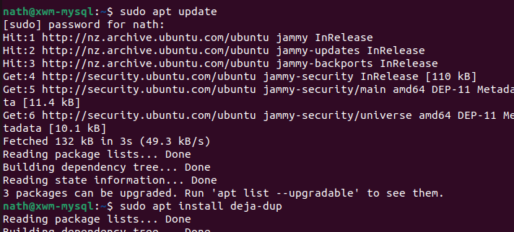

Once installed search for Backup

from Ubuntu’s Show Applications *(Start)* menu.

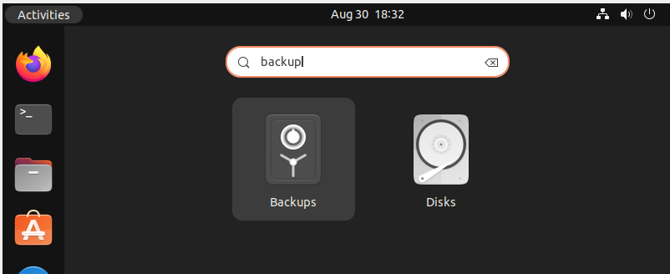

Click Create My First Backup

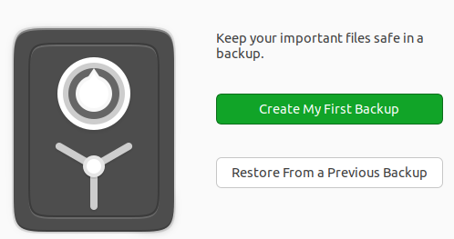

For the meantime, leave the default setting of my home folder: Home(nath)

as folders to be backed up.

In the future I will also need to back up the MySQL folders.

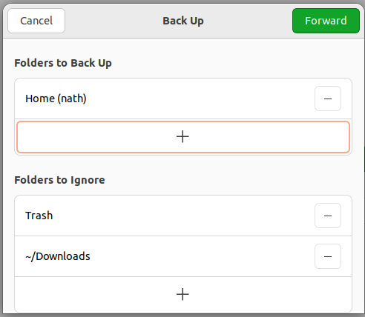

*Next, Select the storage location …*

Save backups to the USB drive

connected to the host machine Ubuntu-LAMP

Storage Location: Network Server

Network Location: smb://ubuntu-lamp.local/ vm_backups

Folder xwm-mysql

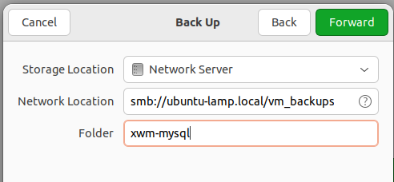

Authenticate as the user nath

on Ubuntu-LAMP

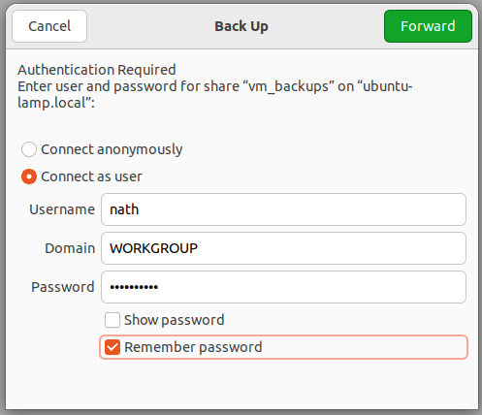

Create the password for the backup

for the virtual machine xwm-mysql

and select Remember password

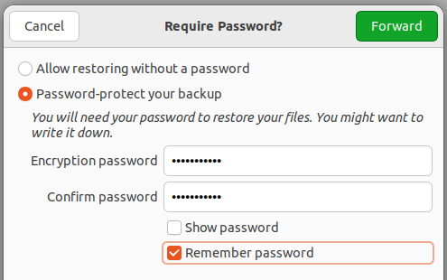

Once the backup completes

select Back up automatically

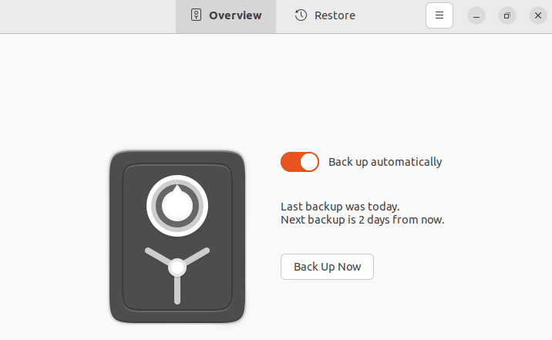

Take a snapshot of the virtual machine

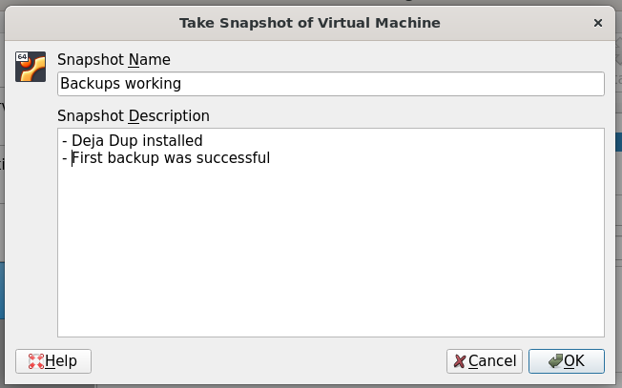

## Remote desktop using xRDP

Install xRDP *(and ‘snake oil’)*

then restart the server

sudo apt update

sudo apt -y install xrdp

sudo adduser xrdp ssl-cert

sudo systemctl restart xrdp

#### Example – install xRDP

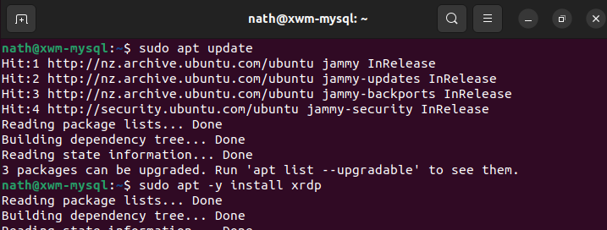

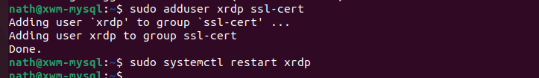

### Configure the firewall for RDP

To allow RDP connections, run the command:

sudo ufw allow 3389

sudo ufw enable

sudo ufw status

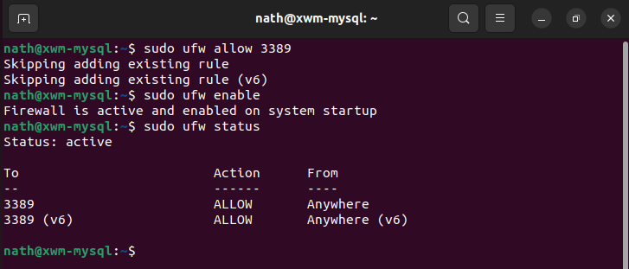

To allow the settings to refresh, restart xwm-mysql

*Next, Remote onto xwm-mysql …*

## Remote onto xwm-mysql

From Naths-Legion

Remote-desktop onto xwm-mysql

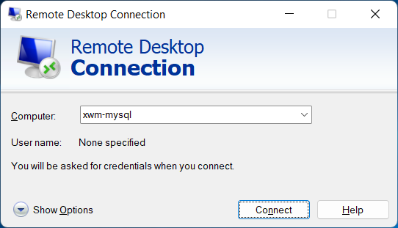

After accepting the connection certificate

xwm-mysql can be seen via remote desktop.

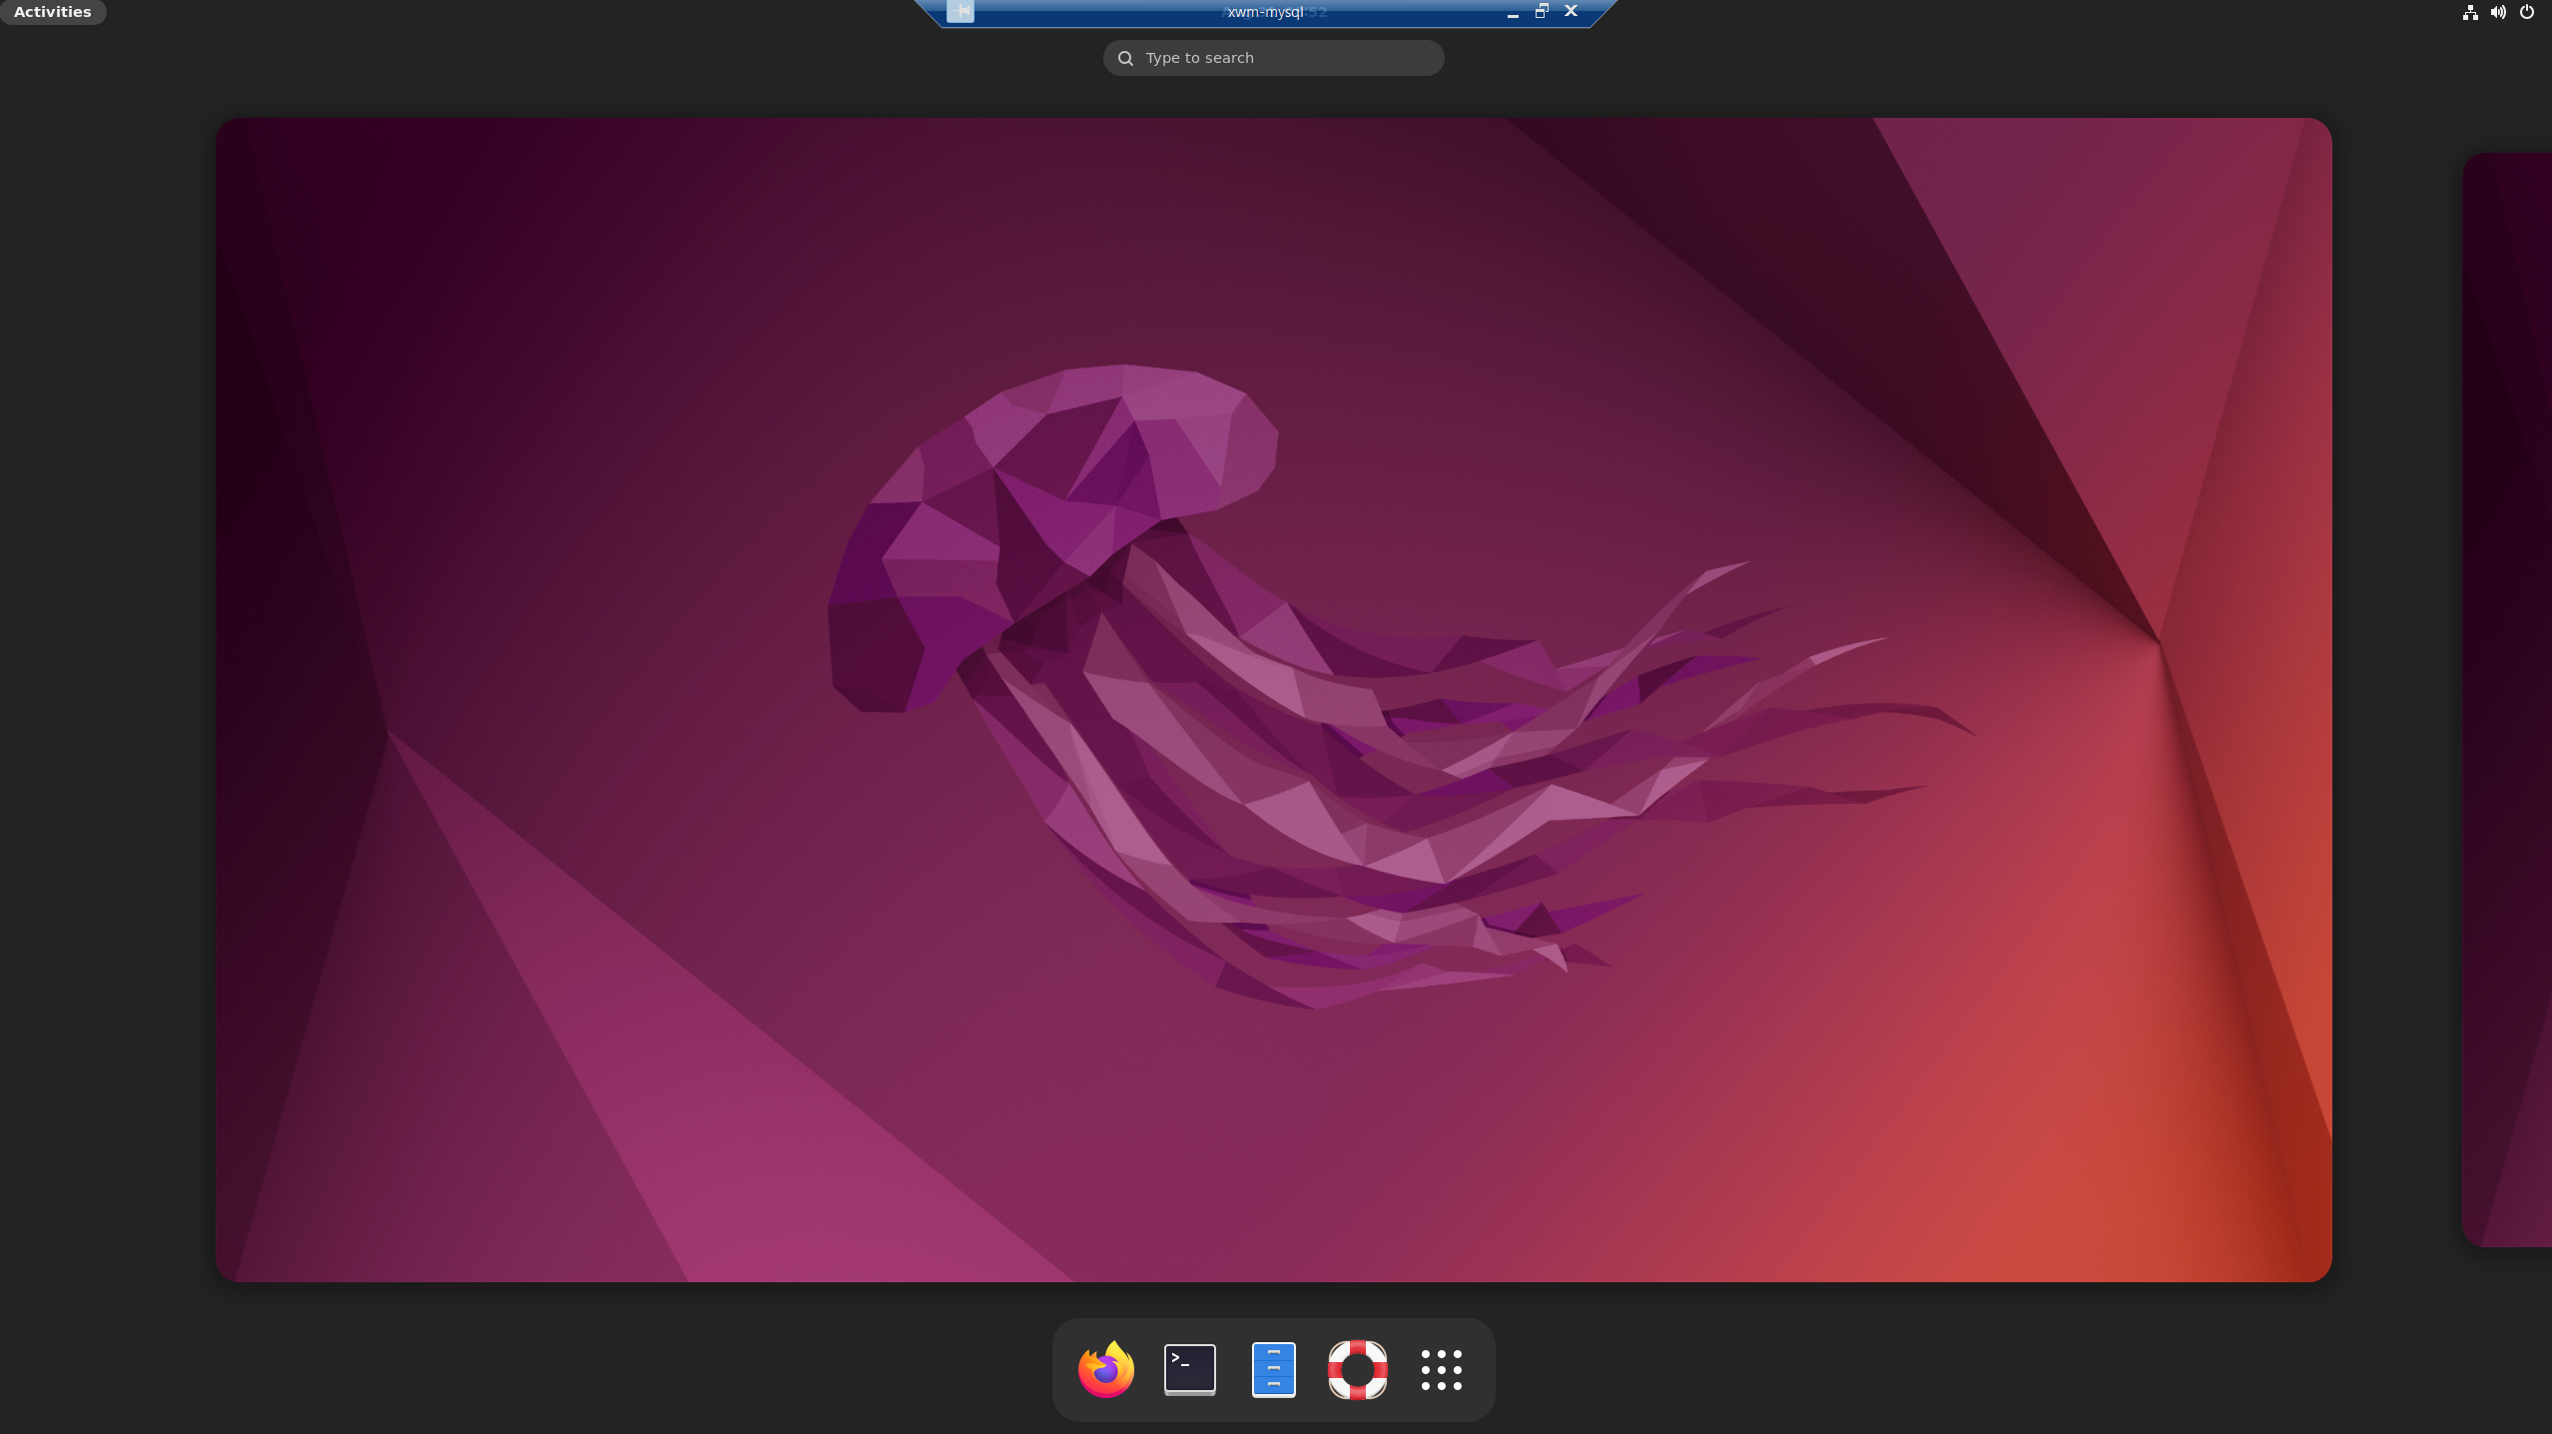

# Install MySQL

To install MySQL run the following command

sudo apt update

sudo apt install mysql-server

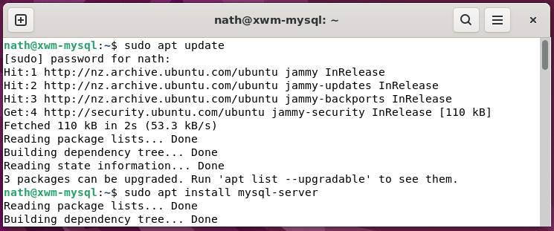

Check MySQL’s status, by running the command

sudo service mysql status

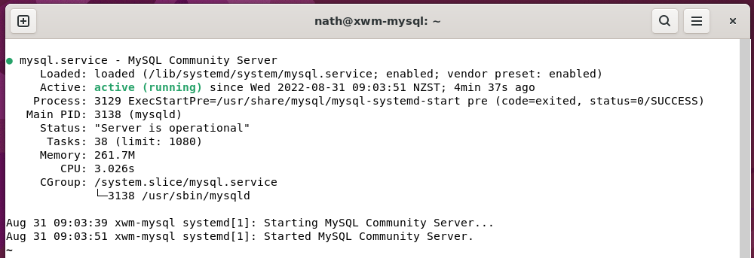

If the server is not running correctly

the following command will start it:

sudo service mysql restart

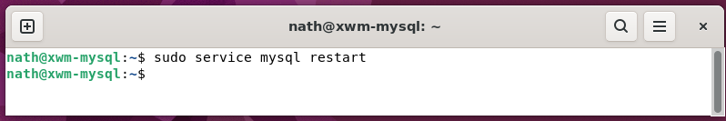

*Next, Create a MySQL user …*

## Create a new user on ‘xwm-mysql’

Open MySQL, by running the command

sudo mysql

#### Example – Run MySQL

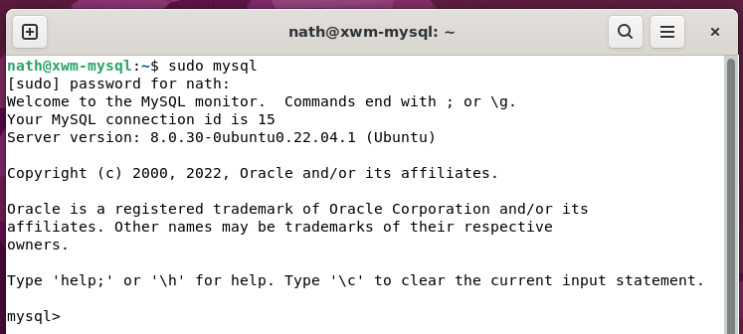

#### Example – Add a new user to MySQL

In MySQL, create the admin user

by running the command

CREATE USER '***username***'@'%' IDENTIFIED BY '***password***';

GRANT ALL PRIVILEGES ON *.* TO '***username***'@'%' WITH GRANT OPTION;

### Login to MySQL as admin

To login to MySQL as admin

run the following command

mysql -h localhost -u root -p

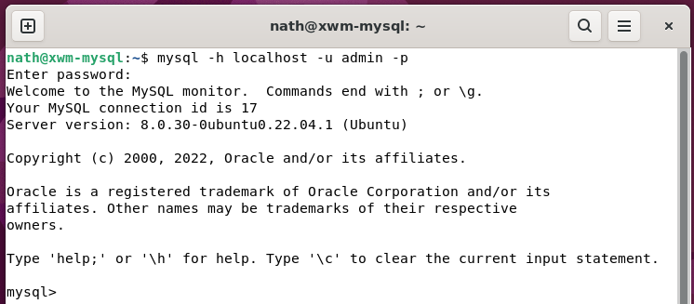

As everything is working up to this point

it’s great time to backup xwm-mysql

and take a Virtual Box snapshot.

#### Deja-Dup

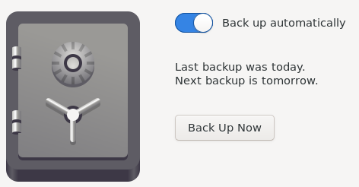

#### VirtualBox

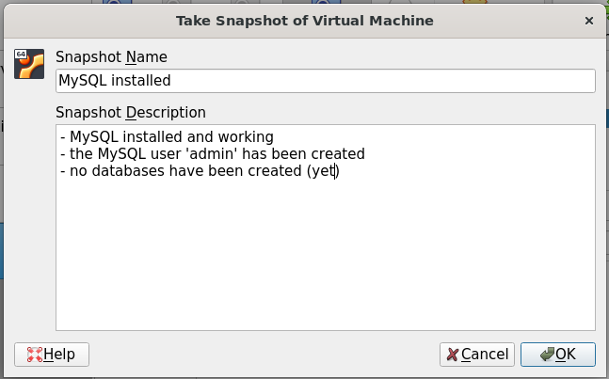

## Change the root password

By default, the MySQL user root

is included on all MySQL installations.

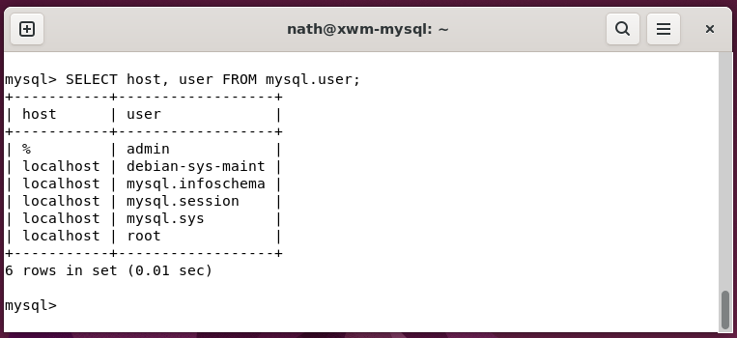

The password is often blank or ‘root’

which is a security risk.

Change the MySQL user root

default password, using the following command.

ALTER USER 'root'@'localhost' IDENTIFIED BY ***'new_password'***;

## Create a MySQL database

Open terminal and run app mysql

mysql -u *‘username’* -p

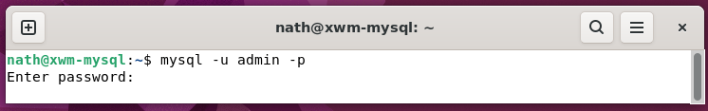

Create a database, for the application ‘The Ultimate Fitness Companion’ *(TUFC)*

#### Example – Create a database

Create the database tufc

CREATE DATABASE IF NOT EXISTS tufc;

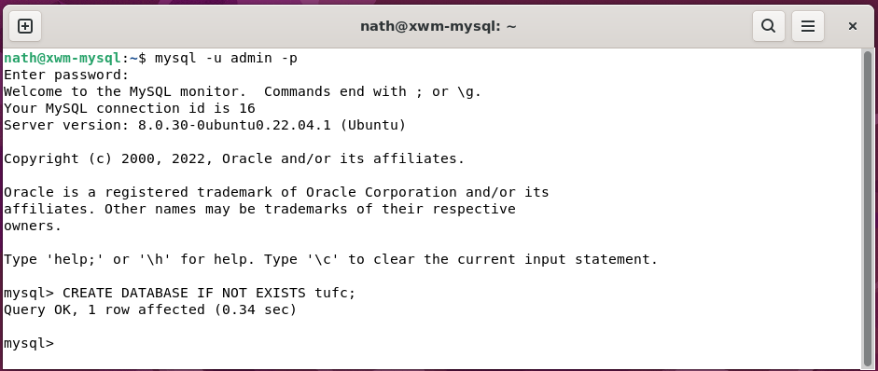

Now, select the database

so, its tables can be created.

USE tufc;

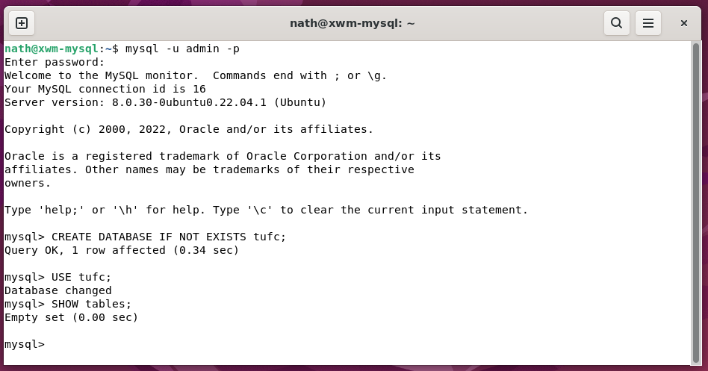

*Next, Create a TUFC table …*

## Create a MySQL table

Before adding a table to a database

it must be properly designed, using the following steps:

***1 – Choose the table name***

***2- Identify objects***

Objects: user

exercise

routine

***3 - Define and name a table for each object***

user: id

email

password

createDate

firstname

lastname

phoneMobile

phoneWork

phoneHome

number

street

city

zip

country

exercise: *to be determined*

routine: *to be determined*

***4 - Identify the attributes for each object***

***5 - Define and name columns for each attribute***

***6 - Identify the primary key***

***7 - Define default values***

***8 – Identify columns that require data***

#### Table - The fully designed table ‘User’

|  |  |  |  |  |  |
| --- | --- | --- | --- | --- | --- |
| **Table: User** |  |  |  |  |  |
| *Field* | *Type* | *Null* | *Key* | *Default* | *Extra* |
| userId | bigint | No | primary | NULL | serial *(bigint, unsigned, not null, auto_increment)* |
| email | varchar(255) | No |  | NULL |  |
| password | varchar(255) | Yes |  | NULL |  |
| createDate | datetime | No |  | NULL |  |
| firstname | varchar(255) | Yes |  | NULL |  |
| lastname | varchar(255) | Yes |  | NULL |  |
| phoneMobile | varchar(255) | Yes |  | NULL |  |
| phoneWork | varchar(255) | Yes |  | NULL |  |
| phoneHome | varchar(255) | Yes |  | NULL |  |
| number | varchar(255) | Yes |  | NULL |  |
| street | varchar(255) | Yes |  | NULL |  |
| city | varchar(255) | Yes |  | NULL |  |
| state | varchar(255) | Yes |  | NULL |  |
| zip | varchar(255) | Yes |  | NULL |  |
| country | varchar(255) | Yes |  | NULL |  |

*Next, Create the table ‘User’ in MySQL …*

To create the table User, use the command

CREATE TABLE();

#### Example - Create the table User

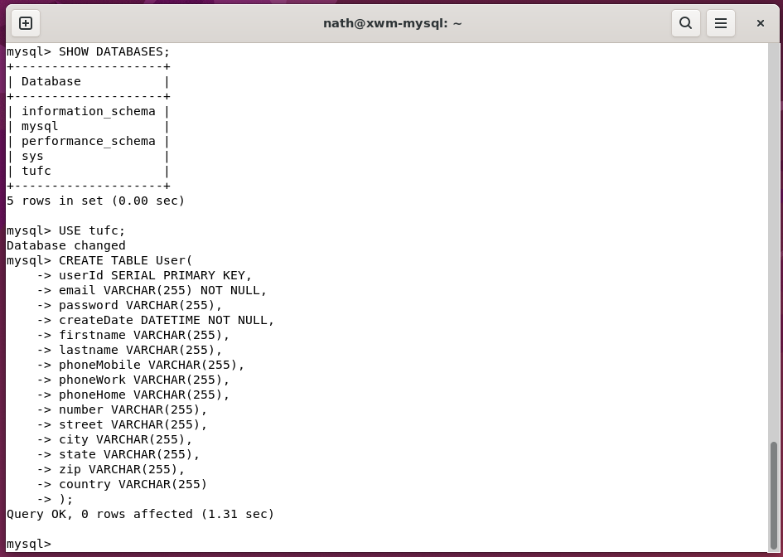

Once the table has been created, review the tables configuration

using the command

EXPLAIN

#### Example – Show a tables configuration

EXPLAIN User;

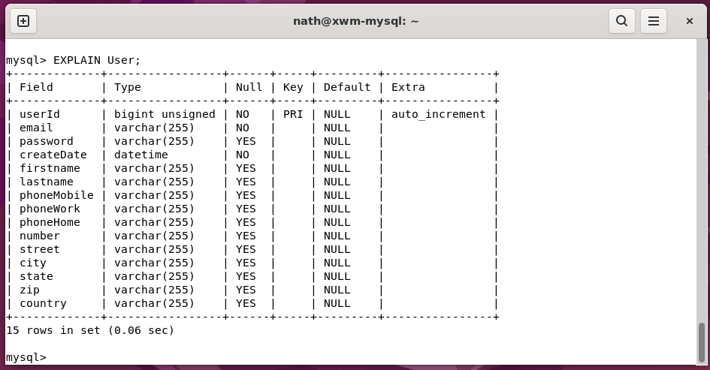

*Next, Insert a row into the table ‘User’ …*

## Insert a row into a table

The table Users

is located in the database tufc

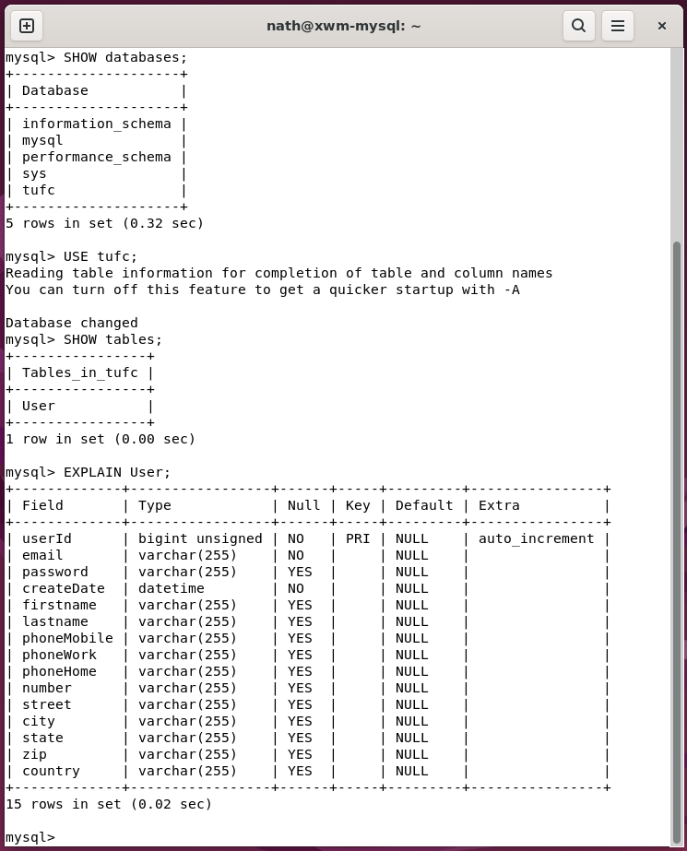

A User object can be inserted into to the table

using the command:

INSERT INTO table_name (column1, column2, column3, ...)  
VALUES (value1, value2, value3, ...);

I’m currently focused on creating XWM’s system structure

so, I won’t go overboard with data

when creating the first row.

However, I do need to include:

* email *(the user’s email address)*
* createDate *(the current time)*

as these cells are configured as NO NULL

The column userId is also set to NOT NULL

however, a value is not required

as it is set to auto increment.

#### Example – INSERT an object

INSERT INTO User (firstname, lastname, email, createDate)

VALUES ('Joe', 'Satriani', 'j.satrianin@mail.com', NOW());

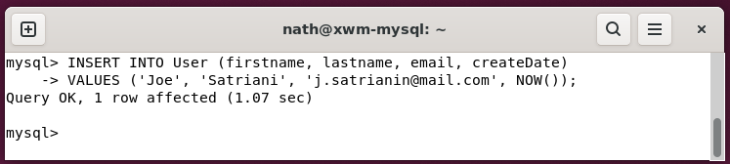

To confirm the new user has been added

to the table User, use the command

SELECT *

FROM table

#### Example – Show a tables content

SELECT *

FROM User;

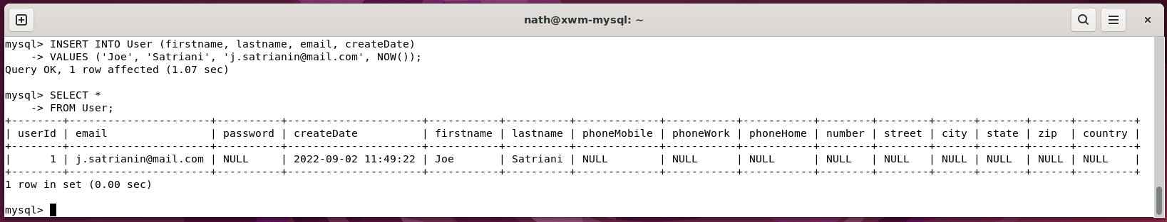

# Create backups

Now that

* Ubuntu and MySQL have been installed
* Remote desktop is working
* The database tufc and the table User have been created

It’s a great time to do backups, including

* a MySQL backup *(mysqldump)*
* an Ubuntu backup *(Deja Dup)*
* take a Virtual Box snapshot

## MySQL backup (mysqldump)

To back up MSQL databases, use the command

mysqldump can be used

Now that the table User has been created

in the database tufc

a MySQL database backup *(‘dump’)* can be created.

### mysqldump

The terminal command **mysqldump**

creates a text file backup of a database.

mysqldump --user=accountname --password=password databasename >path/backupfilename

#### Example – Backup the database ‘tufc’, using mysqldump

Save a backup of the database tufc.sql

to the folder /home/nath/mysql_backups *(***~** *is shorthand for /home/’user’)*

mysqldump -u admin -p tufc >~/mysql_backups/tufc.sql

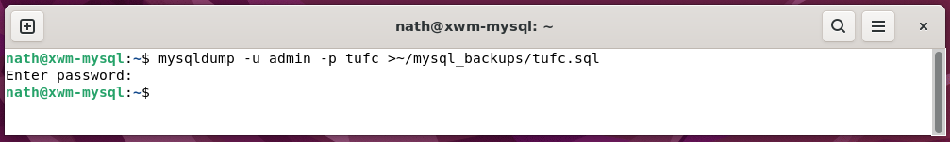

**Note:** Even though this command is run from terminal

-u ***‘username’*** is a MySQL account, not the Ubuntu username.

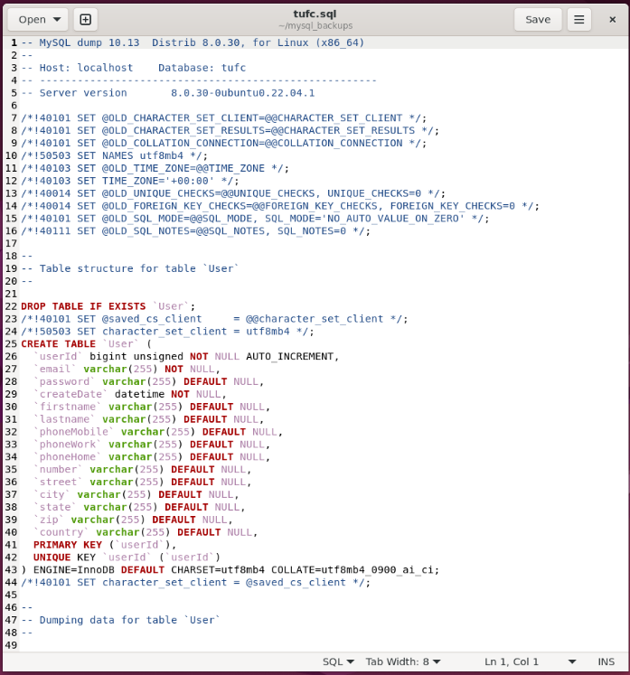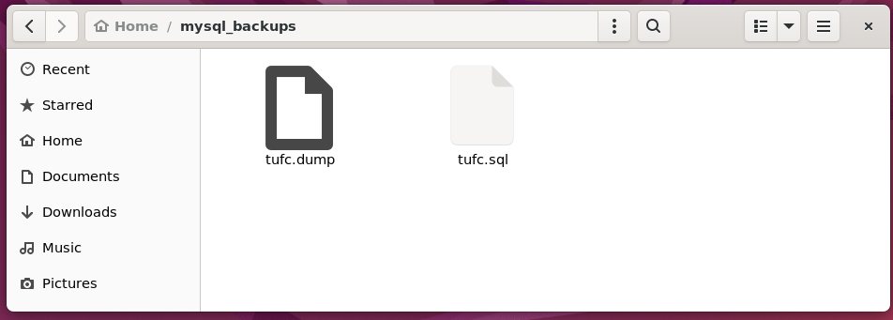

**NOTE:** I’ve created Jira ticket: *XWM14 - Create a 'mysqldump' backup on a network drive*

to do mysqldump network backups.

In the meantime, I’ll manually copy the folder ~/mysql_backups to

* the host machine’s backup USB drive
* and the GitHub repository

#### Create an Ubuntu (Deja Dup) backup

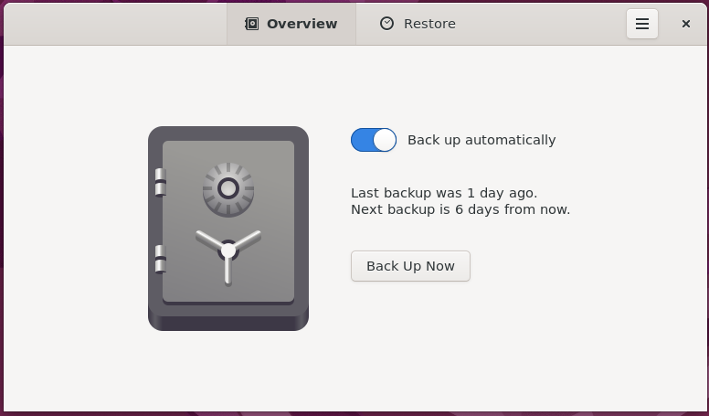

#### Create a VirtualBox snapshot

